Object Oriented Programming in Java – Fundamentals of Java (OOP)

Name: PAU KAWYA

Student Id: 28695

Batch: 22.2

# Question 1.

package nameobj; public class Nameobj

{

public static void main(String[] args)

{

System.out.println("I am PAU Kawya");

}

}

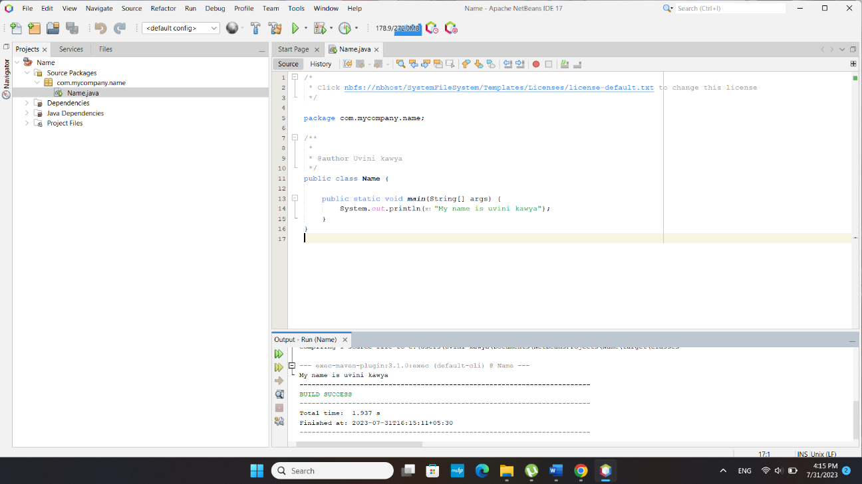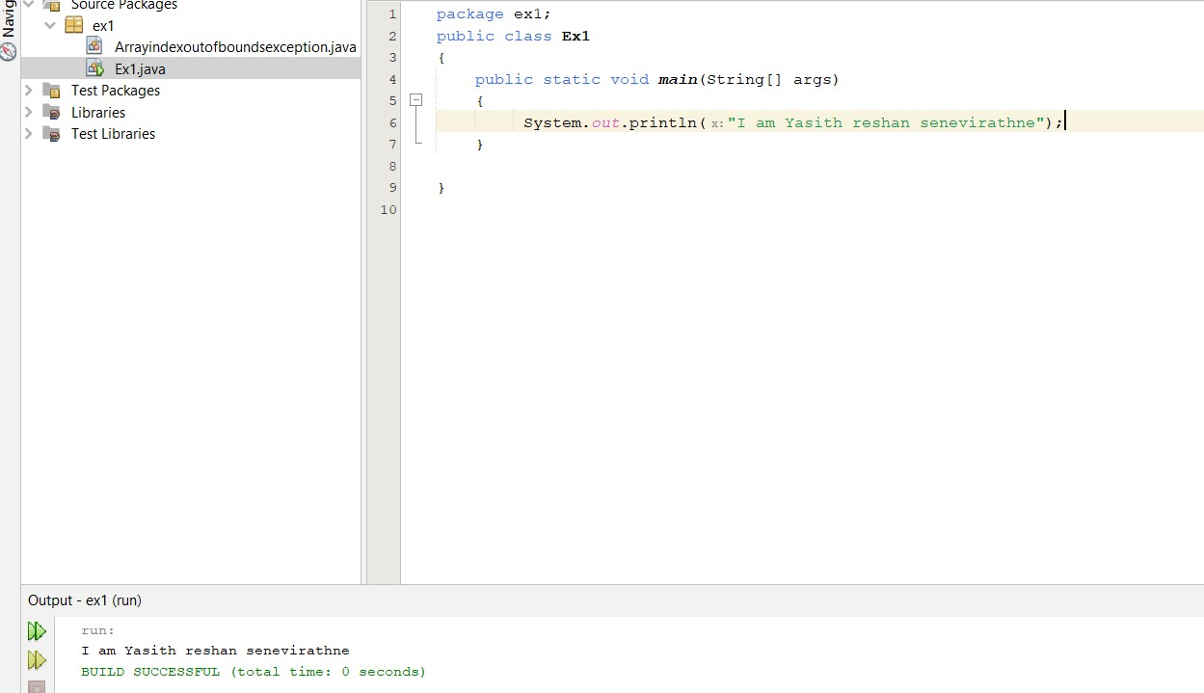

# Question 2.

package nameobj; import java.util.Scanner; public class Nameobj

{

public static void main(String[] args)

{

}

}

# Output:

int no1,no2,no3,product;

Scanner r=new Scanner(System.in); System.out.println("Enter First number: "); no1=r.nextInt();

System.out.println("Enter second number: "); no2=r.nextInt();

System.out.println("Enter third number: "); no3=r.nextInt();

product=no1*no2*no3;

System.out.println("The product of three integers is "+product);

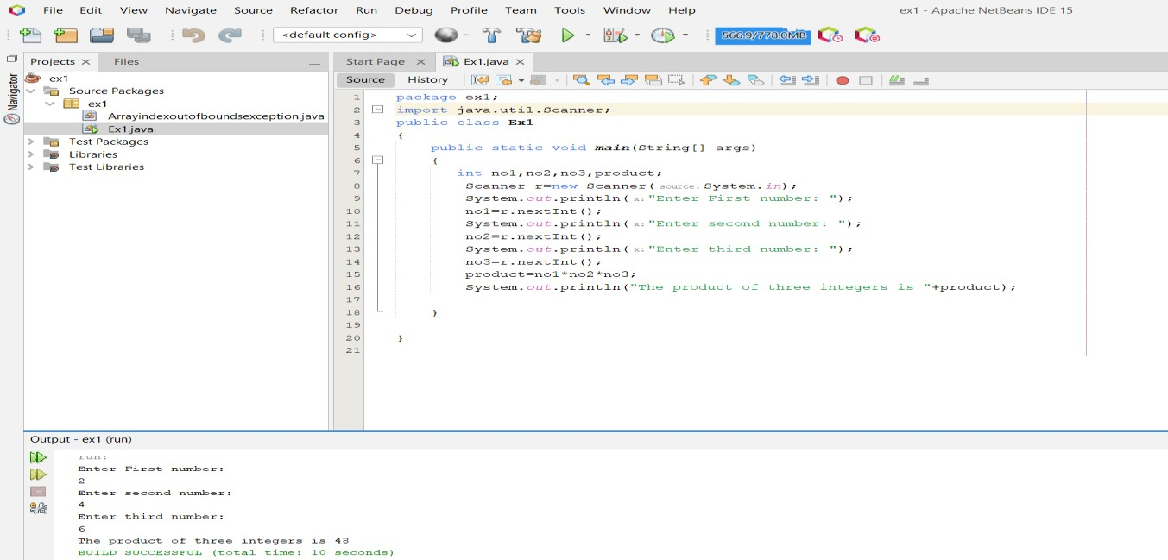

# Question 3.

package nameobj; import java.util.Scanner; public class Nameobj

{

public static void main(String[] args)

{

}

# Output:

float f,c;

Scanner r=new Scanner(System.in); System.out.println("Enter Fahrenheit degree"); f=r.nextFloat();

c=(5.f/9.f)*(f-32.f);

System.out.println("the celcius value is: "+c);

}

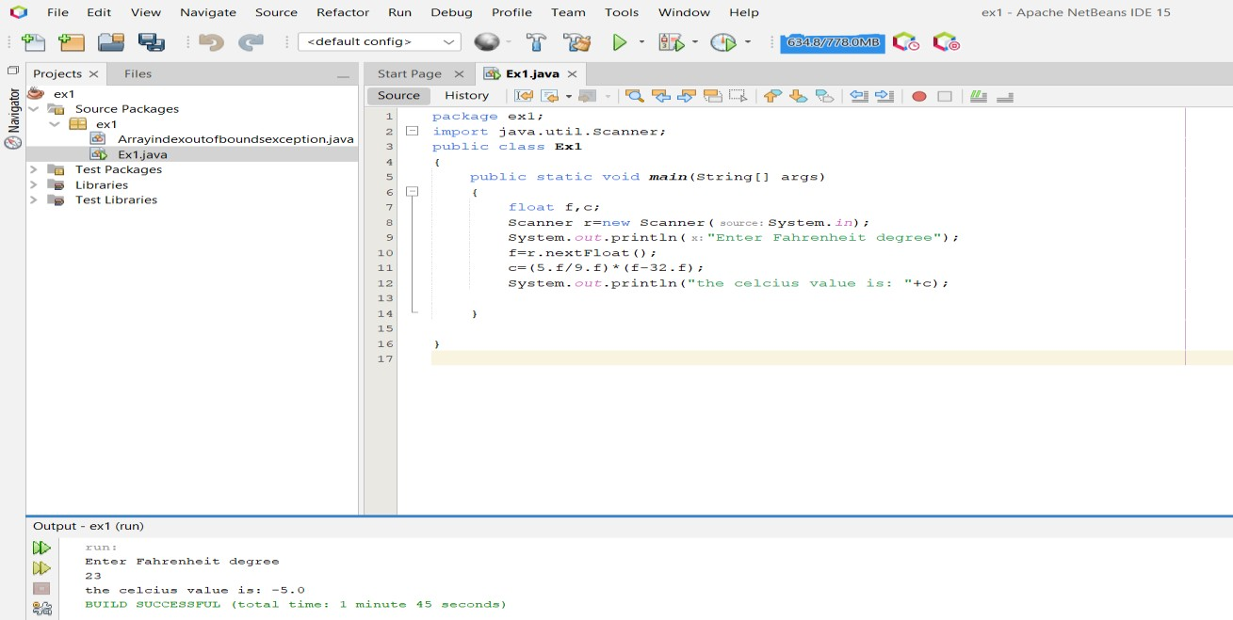

# Question 4.

package nameobj; import java.util.Scanner; public class Nameobj

{

public static void main(String[] args)

{

int n1,n2,n3,sum=0,p=0,min=0,max=0; float avg=0;

Scanner r=new Scanner(System.in); System.out.println("Enter first no"); n1=r.nextInt(); System.out.println("Enter second no"); n2=r.nextInt(); System.out.println("Enter third no"); n3=r.nextInt();

sum=n1+n2+n3; avg=sum/3f; p=n1*n2*n3; n1=max; if(n2>max)

{

max=n2;

}

if(n3>max)

{

max=n3;

}

if(n1<n2 && n1<n3)

{

System.out.println("The min value is "+n1);

}

else if(n2<n3)

{

System.out.println("The min value is "+n2);

}

else

{

System.out.println("The min value is "+n3);

}

System.out.println("The sum is "+sum); System.out.println("The avg is "+avg); System.out.println("The product is "+p);

System.out.println("The max value is "+max);

}

}

# Output:

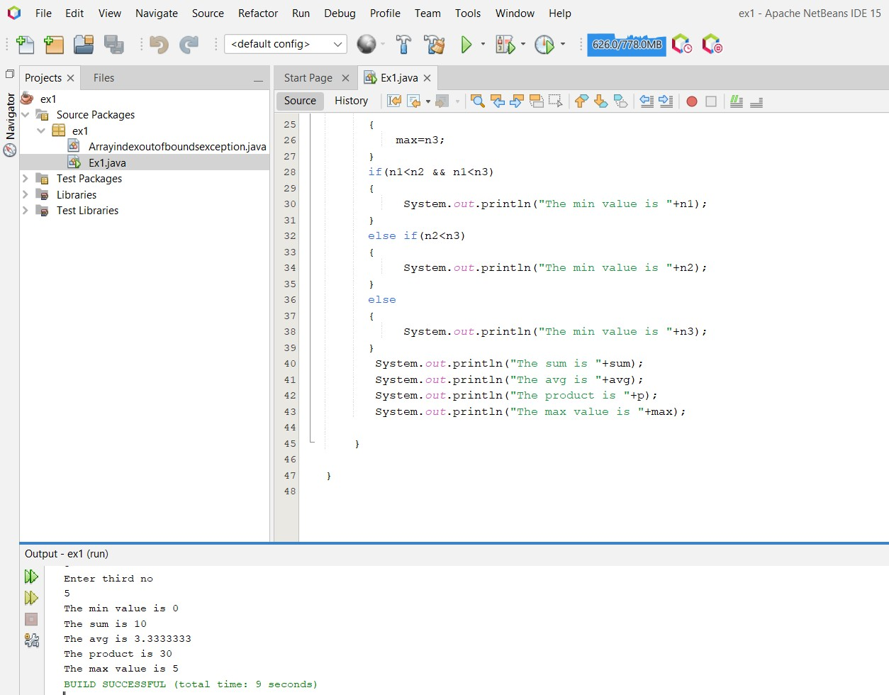

**Question 5.**

package nameobj; import java.util.Scanner; public class Nameobj

{

public static void main(String[] args)

{

float avg=0;

int arr[]=new int[20]; int i,c=1,grade,sum=0;

Scanner r=new Scanner(System.in); for(i=0;i<20;i++)

{

System.out.println("Enter your grade "+(c++)); grade=r.nextInt();

arr[i]=grade; if(grade==1)

{

break;

}

sum=arr[i]+sum; avg=(float)sum/20.00f;

}

for(i=0;i<20;i++)

{

System.out.println(arr[i]);

}

}

# Output:

System.out.println("The Total grade is "+sum); System.out.println("The average grade is "+avg);

}

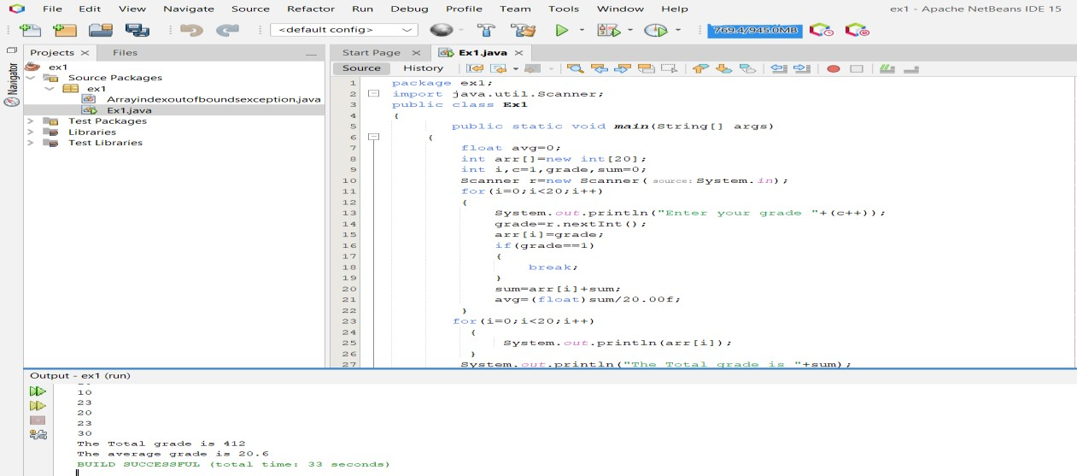

# Question 6.

package datex; public class Date

{

private int month; private int date; private int year;

public Date(int m,int d,int y)

{

date=d; month=m; year=y;

}

public void setmonth(int mo)

{

month=mo;

}

public void setdate(int da)

{

date=da;

}

public void setyear(int ye)

{

year=ye;

}

public int getmonth()

{

return month;

}

public int getdate()

{

return date;

}

public int getyear()

{

return year;

}

public void displayDate()

{

System.out.print("The date is "+date); System.out.print("/"+month); System.out.print("/"+year);

}

}

# Main method.

package datex; public class Datex

{

public static void main(String[] args)

{

}

# Output:

Date r1=new Date(7,2,2001); System.out.println(r1.getdate()); System.out.println(r1.getmonth()); System.out.println(r1.getyear()); r1.setdate(6);

r1.setmonth(2); r1.setyear(2001); r1.displayDate();

}

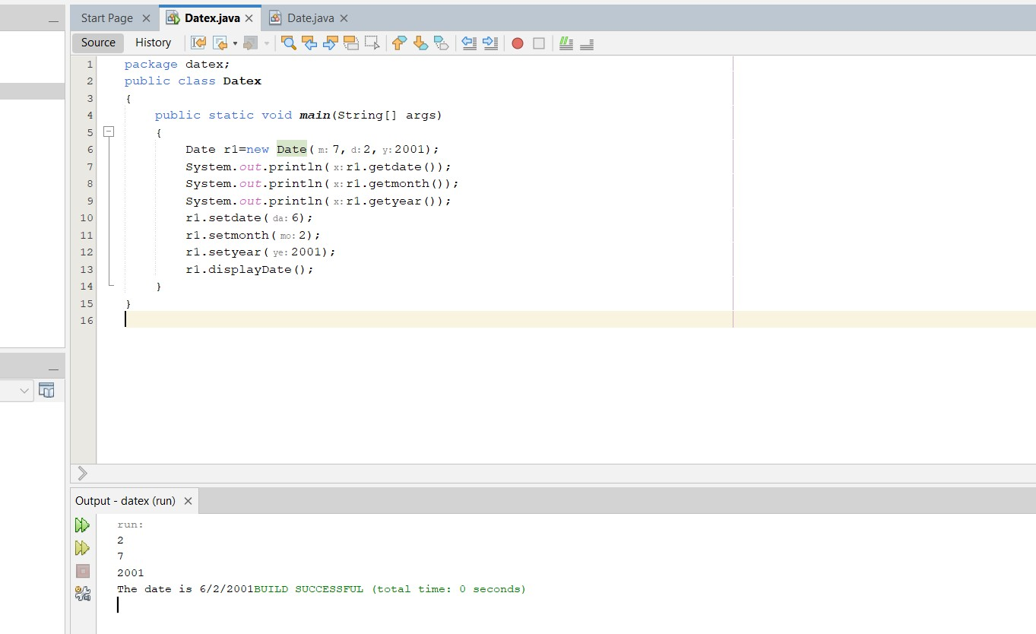

# Question 7.

package itemex; public class Item

{

private int location; private String description;

public Item(int lo,String de)

{

location=lo; description=de;

}

public void setlocation(int l)

{

location=l;

}

public void setdescription(String d)

{

description=d;

}

public int getlocation()

{

return location;

}

public String getdescription()

{

return description;

}

}

# Monster class

package itemex;

public class Monster extends Item

{

private int location; private String description;

public Monster(int location,String description)

{

super(location,description);

}

}

# Main method

package itemex; public class Itemex

{

public static void main(String[] args)

{

Monster r1=new Monster(242,"item"); r1.setlocation(12); r1.setdescription("catch"); System.out.println(r1.getlocation()); System.out.println(r1.getdescription());

}

}

# Output:

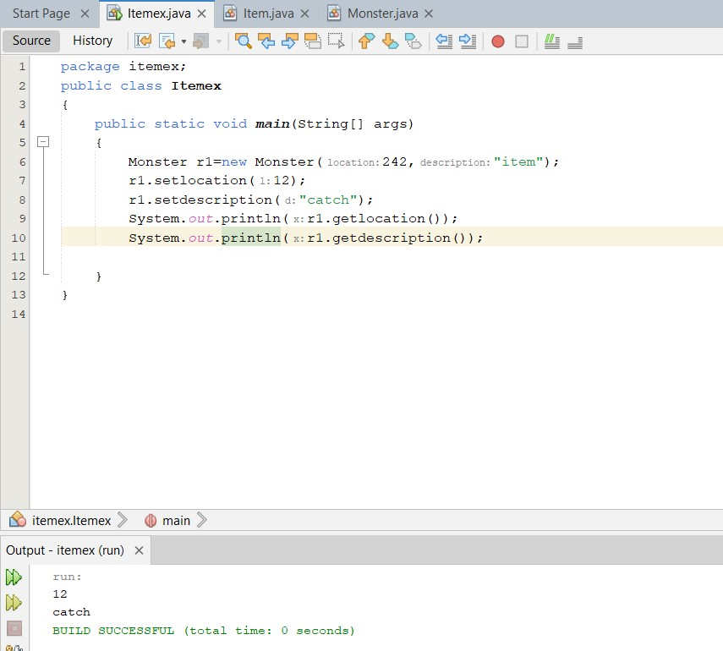

**Question 8.**

package savingobj;

public class SavingsAccount

{

static float annualInterestRate; private float savingsBalanc; public SavingsAccount(float amt)

{

savingsBalanc=amt;

}

public void calculateMonthlyInteres()

{

float mi=savingsBalanc*(annualInterestRate/12.0f); System.out.println("Monthly interest is "+mi); System.out.println("New saving Balance is "+(savingsBalanc+mi));

}

public static void modifyinterestRate(float newrate)

{

annualInterestRate=newrate;

}

}

## Main method

package savingobj; public class Savingobj

{

public static void main(String[] args)

{

SavingsAccount saver1=new SavingsAccount(2000); SavingsAccount saver2=new SavingsAccount(3000); SavingsAccount.annualInterestRate=0.04f; saver1.calculateMonthlyInteres(); saver2.calculateMonthlyInteres(); SavingsAccount.modifyinterestRate(0.05f); saver1.calculateMonthlyInteres(); saver2.calculateMonthlyInteres();

}

}

# Output:

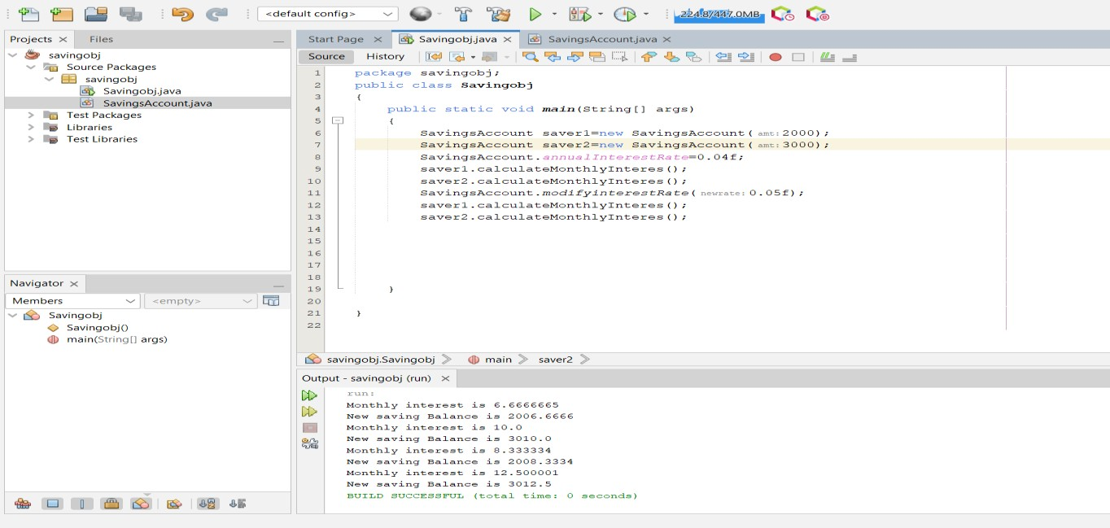

**Question 9.**

Car class

package carobj; public class Car

{

private int speed;

private double regularPrice; private String color;

public Car(int sp,double re,String color)

{

speed=sp; regularPrice=re; this.color=color;

}

public double getSaleprice()

{

return regularPrice;

}

}

Truck class

package carobj;

public class Truck extends Car

{

private int weight;

public Truck(int w,int sp,double re,String color)

{

super(sp, re, color); weight=w;

}

public double getSaleprice()

{

return super.getSaleprice();

}

}

Ford class

package carobj;

public class Ford extends Car

{

private int year;

private int manufacturerDiscount;

public Ford(int y,int man,int sp,double re,String color)

{

super(sp, re, color); year=y;

manufacturerDiscount=man;

}

public double getSaleprice()

{

return super.getSaleprice();

}

}

Sedan class

package carobj;

public class Sedan extends Car

{

private int length;

public Sedan(int len,int sp,double re,String color)

{

super(sp, re, color); length=len;

}

public double getSaleprice()

{

return super.getSaleprice();

}

}

Main method.

package carobj; public class Carobj

{

public static void main(String[] args)

{

Sedan r1=new Sedan(100,110,20000.00f,"red"); Ford r2=new Ford(2001,10,200,300000.00f,"black"); Ford r3=new Ford(1999,14,120,400000.00f,"white"); Car r4=new Car(160,150000.00f,"blue"); System.out.println(r1.getSaleprice()); System.out.println(r2.getSaleprice()); System.out.println(r3.getSaleprice()); System.out.println(r4.getSaleprice());

}

}

# Output:

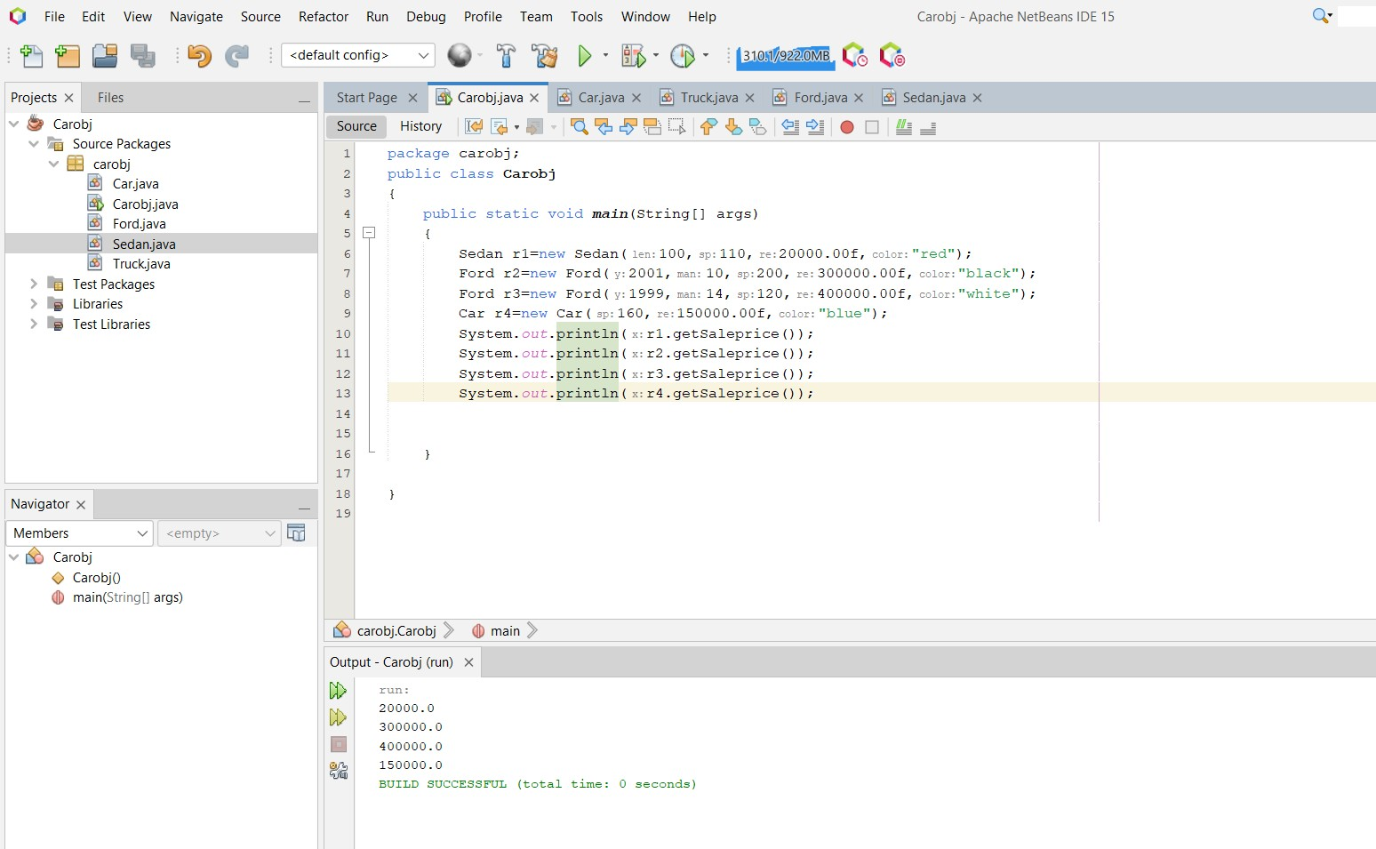

**Question 10.**

Shape class

package shapetest; public class Shape

{

public void draw()

{

System.out.println("Drawing shape");

}

public void erase()

{

System.out.println("Erase shape");

}

}

Circle class

package shapetest;

public class Circle extends Shape

{

@Override

public void draw()

{

System.out.println("Drawing a Circle");

}

@Override

public void erase()

{

System.out.println("Erase circle");

}

}

Triangle class

package shapetest;

public class Triangle extends Shape

{

@Override

public void draw()

{

System.out.println("Drawing a triangle");

}

@Override

public void erase()

{

System.out.println("Erase triangle");

}

}

Square class

package shapetest;

public class Square extends Shape

{

@Override

public void draw()

{

System.out.println("Drawing a square");

}

@Override

public void erase()

{

System.out.println("Erase square");

}

}

Main method

package shapetest; public class Shapetest

{

public static void main(String[] args)

{

# Output:

Shape r=new Circle(); r.draw();

r.erase();

Shape w=new Triangle(); w.draw();

w.erase();

Shape t=new Square(); t.draw();

t.erase();

}

}

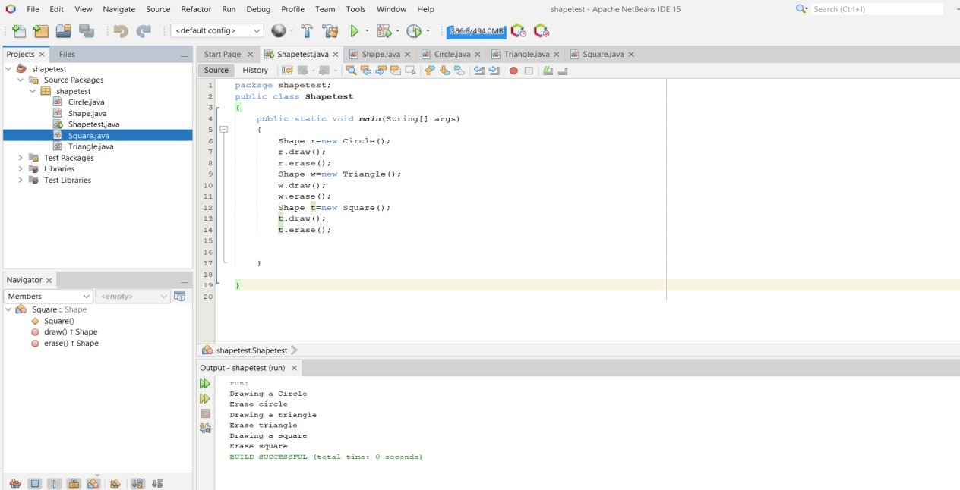

# Abstract Class Example

public abstract class Shape

{

public abstract double area(); public abstract double perimeter();

}

public class Circle extends Shape { public double r,PI;

@Override

public double area()

{

return Math.PI*r *r;

}

@Override

public double perimeter()

{

return 2* Math.PI*r;

}

}

public abstract class Abstractclass

{

public static void main(String[] args)

{

Circle c = new Circle(); c.r=12;

c.PI=3.14;

System.out.print("\nArea = " + c.area()); System.out.print("\nPerimeter = " + c.perimeter());

}

}

public class Baseclass

{

public void display()

{

System.out.println("Debugging method called in base class");

}

}

public class Drivedclass extends Baseclass

{

@Override

public void display()

{

System.out.println("Debugging method called in derived class");

}

}

public class Abstractclass

{

public static void main(String[] args)

{

{

Baseclass b = new Baseclass(); b.display();

Drivedclass d = new Drivedclass(); d.display();

}

}

}

# Question 11.

## Interface

package test1; public interface A

{

}

## Myclass

void method1(); void method2();

package test1;

public class Myclass implements A

{

public void method1()

{

}

public void method2()

{

}

}

## Test interface

package test2; public interface Test

{

void square();

}

## Arithmetic class

package test2;

public class Arithmetic implements Test

{

public void square()

{

}

}

## Main method

package test2; public class Testint

{

public static void main(String[] args)

{

Arithmetic w=new Arithmetic(); w.square();

}

}

# Question 12.

package com.mycompany.exceptionhandling; import java.util.Scanner;

public class ExceptionHandling

{

public static void main(String[] args)

{

try

{

Scanner h=new Scanner(System.in);

int s;

System.out.println("Enter Array Size:"); s=h.nextInt();

int arr[]=new int[s]; if(s>0)

{

System.out.println("Array size is Positive");

}

}

catch(NegativeArraySizeException e)

{

System.out.print(e);

}

}

}

# Output:

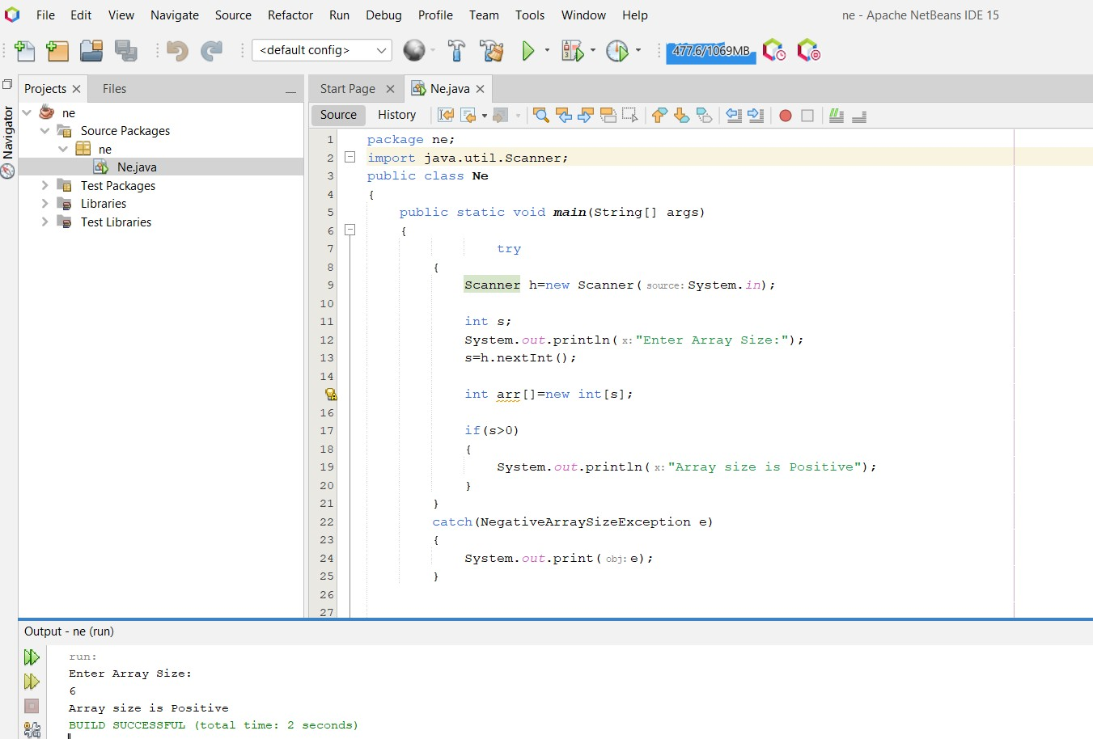

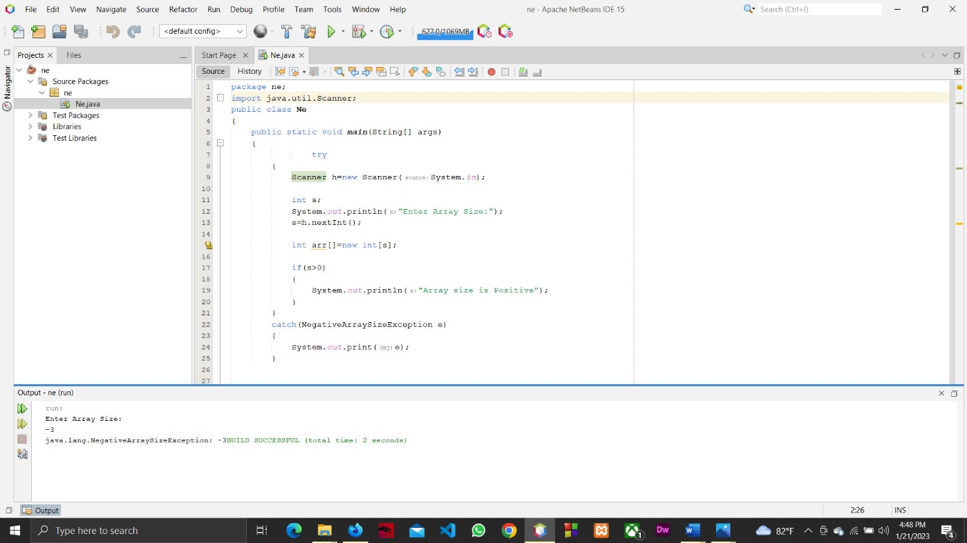

## Example for multiple catch statements

import java.util.Scanner; public class Multiplecatch {

public static void main(String[] args)

{

Scanner m=new Scanner(System.in); int s;

System.out.print("Enter size of array:"); s=m.nextInt();

try

{

int arr[]=new int[s];

System.out.print("Value of last element:" + arr[4]);

}

catch(ArrayIndexOutOfBoundsException E1)

{

System.out.print(E1);

}

catch(NegativeArraySizeException E2)

{

System.out.print(E2);

}

}

}

## Example for Exception Precedence

public class EPrecedence

{

public static void main(String[] args)

{

try

{

int[] arr=new int[8];

}

catch(ArrayIndexOutOfBoundsException p)

{

System.out.print("\n Caught ArrayIndexOutOfBounndsException:"+p.getMessage());

}

catch(Exception p)

{

System.out.println("Caught Exeption:"+p.getMessage());

}

}

}

## Try/Catch with Finally Clause

public class Finallyclause

{

public static void main(String[] args)

{

try

{

int arr[]=new int[7];

System.out.print("Last Element Value:"+arr[8]);

}

catch(ArrayIndexOutOfBoundsException f1){ System.out.print(f1);

}

finally

{

System.out.println("Finally block is here");

}

}

}

## Usage of throws Clause

public class Age {

public void validateAge(int age)throws ArithmeticException

{

if(age<18)

throw new ArithmeticException("Access Denied"); else

System.out.print("welcome!");

}

}

public class TestAge

{

public static void main(String[] args)

{

Age a=new Age();

try

{

a.validateAge(16);

}

catch(ArithmeticException e)

{

System.out.print(e.getMessage());

}

}

}

## User defined Exceptions

public class ValidateAge extends Exception

{

String s;

public ValidateAge(String a)

{

s=a;

}

public String toString()

{

return s;

}

}

public class Age

{

public void checkAge(int year)throws ValidateAge

{

if(year>=13 && year<=19)

throw new ValidateAge("You ara a Teenager"); else

System.out.println("You are not a Teenager");

}

}

public class Userdefinedexception {

public static void main(String[] args)

{

Age a=new Age();

try

{

a.checkAge(15);

}

catch(ValidateAge e)

{

System.out.println(e);

}

}

}

# Output:

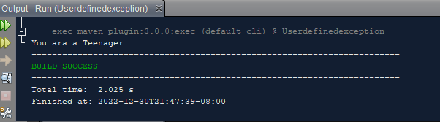

**Question 13.**

package A13;

public class MyThread implements Runnable

{

public MyThread()

{

super();

}

public void run()

{

try{

Thread.sleep(500);

}catch(InterruptedException e)

{

e.printStackTrace();

}

}

}

Main method

package A13; public class Q13

{

public static void main(String[] args)

{

Thread thread = new Thread(new MyThread()); thread.start();

for(int i=0;i<10;i++)

{

System.out.println("Main thread: "+i);

}

}

}

# Output:

run:

Main thread: 0

Main thread: 1

Main thread: 2

Main thread: 3

Main thread: 4

Main thread: 5

Main thread: 6

Main thread: 7

Main thread: 8

Main thread: 9

# Question 14.

**JFrame**

/*

* Click nbfs://nbhost/SystemFileSystem/Templates/Licenses/license-default.txt to change this license
* Click nbfs://nbhost/SystemFileSystem/Templates/GUIForms/JFrame.java to edit this template

*/

package testgui;

/**

*

* @author Yasith Reshan

*/

public class Applet extends javax.swing.JFrame {

/**

* + Creates new form Applet

*/

public Applet() { initComponents();

}

/**

* This method is called from within the constructor to initialize the form.
* WARNING: Do NOT modify this code. The content of this method is always
* regenerated by the Form Editor.

*/ @SuppressWarnings("unchecked")

// <editor-fold defaultstate="collapsed" desc="Generated Code"> private void initComponents() {

jLabel1 = new javax.swing.JLabel(); jTextField1 = new javax.swing.JTextField();

jRadioButton1 = new javax.swing.JRadioButton(); jRadioButton2 = new javax.swing.JRadioButton(); jButton1 = new javax.swing.JButton();

jLabel2 = new javax.swing.JLabel();

setDefaultCloseOperation(javax.swing.WindowConstants.EXIT_ON_CLOSE); setTitle("Applet viewer : Testingphase.class ");

jLabel1.setText("Applet");

jTextField1.addActionListener(new java.awt.event.ActionListener() { public void actionPerformed(java.awt.event.ActionEvent evt) {

jTextField1ActionPerformed(evt);

}

});

jRadioButton1.setText("To Celcius"); jRadioButton2.setText("To Kelvin"); jButton1.setText("Show result");

jButton1.addActionListener(new java.awt.event.ActionListener() { public void actionPerformed(java.awt.event.ActionEvent evt) {

jButton1ActionPerformed(evt);

}

});

jLabel2.setText("Enter Ferenheit, Choose an option to convert and Click show Result");

javax.swing.GroupLayout layout = new javax.swing.GroupLayout(getContentPane()); getContentPane().setLayout(layout);

layout.setHorizontalGroup( layout.createParallelGroup(javax.swing.GroupLayout.Alignment.LEADING)

.addGroup(layout.createSequentialGroup()

.addGroup(layout.createParallelGroup(javax.swing.GroupLayout.Alignment.LEADING)

.addGroup(layout.createSequentialGroup()

.addContainerGap()

.addComponent(jLabel1, javax.swing.GroupLayout.PREFERRED_SIZE, 52, javax.swing.GroupLayout.PREFERRED_SIZE))

.addGroup(layout.createSequentialGroup()

.addGap(43, 43, 43)

.addComponent(jTextField1, javax.swing.GroupLayout.PREFERRED_SIZE, 120, javax.swing.GroupLayout.PREFERRED_SIZE)

.addGap(29, 29, 29)

.addComponent(jRadioButton1, javax.swing.GroupLayout.PREFERRED_SIZE, 98, javax.swing.GroupLayout.PREFERRED_SIZE)

.addGap(18, 18, 18)

.addComponent(jRadioButton2, javax.swing.GroupLayout.PREFERRED_SIZE, 98, javax.swing.GroupLayout.PREFERRED_SIZE)

.addGap(18, 18, 18)

.addComponent(jButton1))

.addGroup(layout.createSequentialGroup()

.addGap(51, 51, 51)

.addComponent(jLabel2, javax.swing.GroupLayout.PREFERRED_SIZE, 455, javax.swing.GroupLayout.PREFERRED_SIZE)))

.addContainerGap(74, Short.MAX_VALUE))

);

layout.setVerticalGroup( layout.createParallelGroup(javax.swing.GroupLayout.Alignment.LEADING)

.addGroup(layout.createSequentialGroup()

.addComponent(jLabel1, javax.swing.GroupLayout.PREFERRED_SIZE, 27, javax.swing.GroupLayout.PREFERRED_SIZE)

.addPreferredGap(javax.swing.LayoutStyle.ComponentPlacement.RELATED)

.addGroup(layout.createParallelGroup(javax.swing.GroupLayout.Alignment.BASELINE)

.addComponent(jTextField1, javax.swing.GroupLayout.PREFERRED_SIZE, javax.swing.GroupLayout.DEFAULT_SIZE, javax.swing.GroupLayout.PREFERRED_SIZE)

.addComponent(jRadioButton1)

.addComponent(jRadioButton2)

.addComponent(jButton1))

.addGap(18, 18, 18)

.addComponent(jLabel2, javax.swing.GroupLayout.PREFERRED_SIZE, 28, javax.swing.GroupLayout.PREFERRED_SIZE)

.addGap(0, 47, Short.MAX_VALUE))

);

pack();

}// </editor-fold>

private void jTextField1ActionPerformed(java.awt.event.ActionEvent evt) {

// TODO add your handling code here:

}

private void jButton1ActionPerformed(java.awt.event.ActionEvent evt) {

// TODO add your handling code here: if(jRadioButton1.isSelected()) {

float num=Float.parseFloat(jTextField1.getText()); float num_1 =5*(num-32)/9; jTextField1.setText(String.valueOf(num_1));

}else if(jRadioButton2.isSelected()){

float num=Float.parseFloat(jTextField1.getText()); float num_1 =(5*(num-32)/9)+273.15f; jTextField1.setText(String.valueOf(num_1));

}

}

/**

* @param args the command line arguments

*/

public static void main(String args[]) {

/* Set the Nimbus look and feel */

//<editor-fold defaultstate="collapsed" desc=" Look and feel setting code (optional) ">

/* If Nimbus (introduced in Java SE 6) is not available, stay with the default look and feel.

* For details see <http://download.oracle.com/javase/tutorial/uiswing/lookandfeel/plaf.html>

*/ try {

for (javax.swing.UIManager.LookAndFeelInfo info : javax.swing.UIManager.getInstalledLookAndFeels()) {

if ("Nimbus".equals(info.getName())) { javax.swing.UIManager.setLookAndFeel(info.getClassName()); break;

}

}

} catch (ClassNotFoundException ex) {

java.util.logging.Logger.getLogger(Applet.class.getName()).log(java.util.logging.Level.SEVERE, null, ex);

} catch (InstantiationException ex) {

java.util.logging.Logger.getLogger(Applet.class.getName()).log(java.util.logging.Level.SEVERE, null, ex);

} catch (IllegalAccessException ex) {

java.util.logging.Logger.getLogger(Applet.class.getName()).log(java.util.logging.Level.SEVERE, null, ex);

} catch (javax.swing.UnsupportedLookAndFeelException ex) {

java.util.logging.Logger.getLogger(Applet.class.getName()).log(java.util.logging.Level.SEVERE, null, ex);

}

//</editor-fold>

/* Create and display the form */ java.awt.EventQueue.invokeLater(new Runnable() {

public void run() {

new Applet().setVisible(true);

}

});

}

// Variables declaration - do not modify private javax.swing.JButton jButton1; private javax.swing.JLabel jLabel1; private javax.swing.JLabel jLabel2;

private javax.swing.JRadioButton jRadioButton1; private javax.swing.JRadioButton jRadioButton2; private javax.swing.JTextField jTextField1;

// End of variables declaration

}

## Main method.

package testgui; public class Testgui

{

public static void main(String[] args)

{

Applet r=new Applet(); r.show();

}

}

# Output:

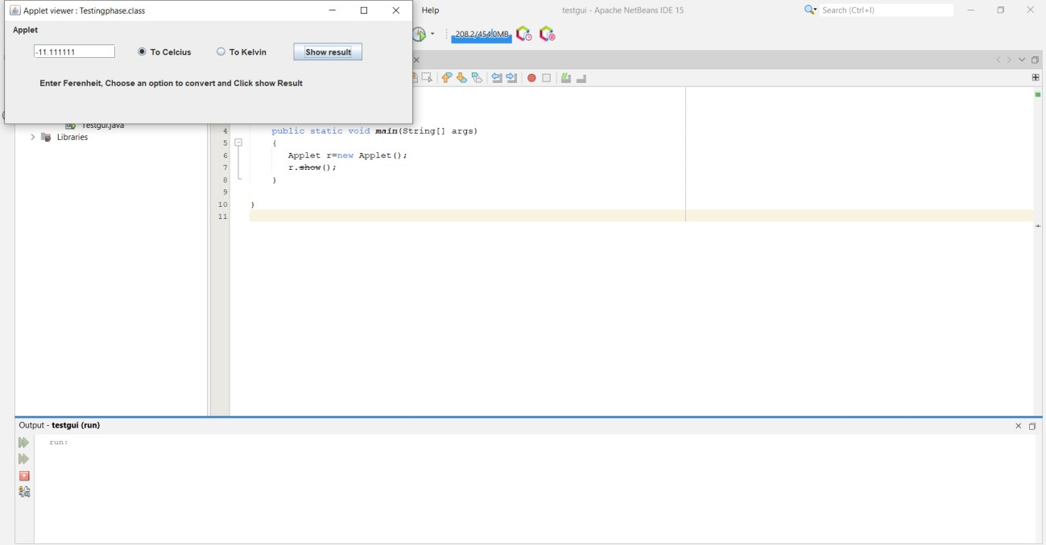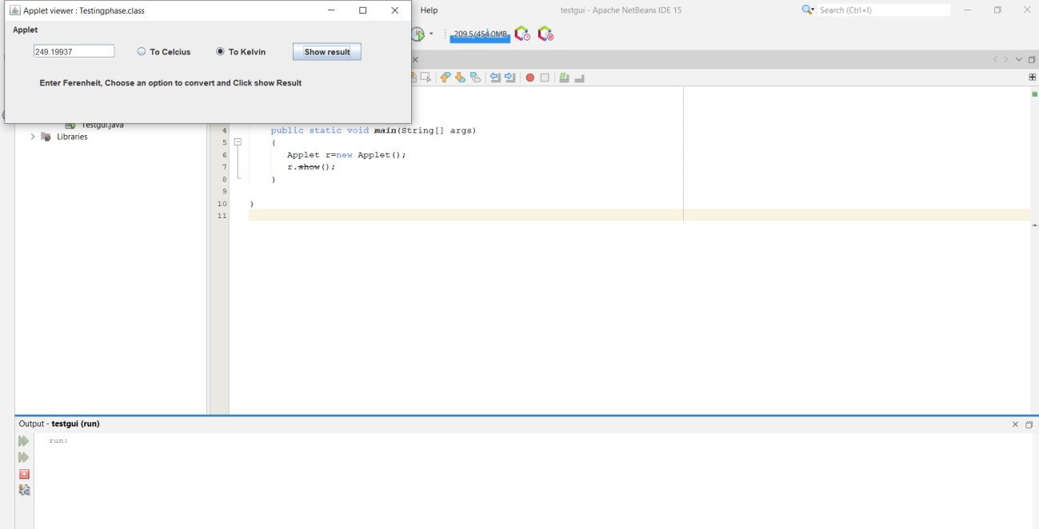

**Question 15.**

/*

* Click nbfs://nbhost/SystemFileSystem/Templates/Licenses/license-default.txt to change this license
* Click nbfs://nbhost/SystemFileSystem/Templates/GUIForms/JFrame.java to edit this template

*/

package q15calc;

/**

*

* @author Yasith Reshan

*/

public class Calc extends javax.swing.JFrame {

/**

* + Creates new form Calc

*/

public Calc() { initComponents();

}

/**

* + This method is called from within the constructor to initialize the form.
  + WARNING: Do NOT modify this code. The content of this method is always
  + regenerated by the Form Editor.

*/ @SuppressWarnings("unchecked")

// <editor-fold defaultstate="collapsed" desc="Generated Code"> private void initComponents() {

jPanel1 = new javax.swing.JPanel(); jPanel2 = new javax.swing.JPanel(); jLabel1 = new javax.swing.JLabel(); jButton1 = new javax.swing.JButton(); jButton2 = new javax.swing.JButton(); jButton3 = new javax.swing.JButton(); jButton4 = new javax.swing.JButton(); jButton5 = new javax.swing.JButton(); jButton6 = new javax.swing.JButton(); jButton7 = new javax.swing.JButton(); jButton8 = new javax.swing.JButton(); jButton9 = new javax.swing.JButton();

jButton10 = new javax.swing.JButton(); jButton11 = new javax.swing.JButton(); jButton12 = new javax.swing.JButton(); jButton13 = new javax.swing.JButton(); jButton14 = new javax.swing.JButton(); jButton15 = new javax.swing.JButton(); jButton16 = new javax.swing.JButton();

setDefaultCloseOperation(javax.swing.WindowConstants.EXIT_ON_CLOSE); setTitle("Simple calc");

jPanel1.setBackground(new java.awt.Color(204, 204, 204));

jPanel2.setBackground(new java.awt.Color(255, 255, 255));

jLabel1.setFont(new java.awt.Font("Segoe UI", 0, 14)); // NOI18N jLabel1.setHorizontalAlignment(javax.swing.SwingConstants.RIGHT);

javax.swing.GroupLayout jPanel2Layout = new javax.swing.GroupLayout(jPanel2); jPanel2.setLayout(jPanel2Layout);

jPanel2Layout.setHorizontalGroup( jPanel2Layout.createParallelGroup(javax.swing.GroupLayout.Alignment.LEADING)

.addComponent(jLabel1, javax.swing.GroupLayout.DEFAULT_SIZE, 229, Short.MAX_VALUE)

);

jPanel2Layout.setVerticalGroup( jPanel2Layout.createParallelGroup(javax.swing.GroupLayout.Alignment.LEADING)

.addComponent(jLabel1, javax.swing.GroupLayout.Alignment.TRAILING, javax.swing.GroupLayout.DEFAULT_SIZE, 40, Short.MAX_VALUE)

);

jButton1.setText("0");

jButton1.addActionListener(new java.awt.event.ActionListener() { public void actionPerformed(java.awt.event.ActionEvent evt) {

jButton1ActionPerformed(evt);

}

});

jButton2.setText("1");

jButton2.addActionListener(new java.awt.event.ActionListener() { public void actionPerformed(java.awt.event.ActionEvent evt) {

jButton2ActionPerformed(evt);

}

});

jButton3.setText("2");

jButton3.addActionListener(new java.awt.event.ActionListener() { public void actionPerformed(java.awt.event.ActionEvent evt) {

jButton3ActionPerformed(evt);

}

});

jButton4.setText("3");

jButton4.addActionListener(new java.awt.event.ActionListener() { public void actionPerformed(java.awt.event.ActionEvent evt) {

jButton4ActionPerformed(evt);

}

});

jButton5.setText("4");

jButton5.addActionListener(new java.awt.event.ActionListener() { public void actionPerformed(java.awt.event.ActionEvent evt) {

jButton5ActionPerformed(evt);

}

});

jButton6.setText("5");

jButton6.addActionListener(new java.awt.event.ActionListener() { public void actionPerformed(java.awt.event.ActionEvent evt) {

jButton6ActionPerformed(evt);

}

});

jButton7.setText("6");

jButton7.addActionListener(new java.awt.event.ActionListener() { public void actionPerformed(java.awt.event.ActionEvent evt) {

jButton7ActionPerformed(evt);

}

});

jButton8.setText("7");

jButton8.addActionListener(new java.awt.event.ActionListener() { public void actionPerformed(java.awt.event.ActionEvent evt) {

jButton8ActionPerformed(evt);

}

});

jButton9.setText("8");

jButton9.addActionListener(new java.awt.event.ActionListener() { public void actionPerformed(java.awt.event.ActionEvent evt) {

jButton9ActionPerformed(evt);

}

});

jButton10.setText("9");

jButton10.addActionListener(new java.awt.event.ActionListener() { public void actionPerformed(java.awt.event.ActionEvent evt) {

jButton10ActionPerformed(evt);

}

});

jButton11.setText("+");

jButton11.addActionListener(new java.awt.event.ActionListener() { public void actionPerformed(java.awt.event.ActionEvent evt) {

jButton11ActionPerformed(evt);

}

});

jButton12.setText("-");

jButton12.addActionListener(new java.awt.event.ActionListener() { public void actionPerformed(java.awt.event.ActionEvent evt) {

jButton12ActionPerformed(evt);

}

});

jButton13.setText("*");

jButton13.addActionListener(new java.awt.event.ActionListener() { public void actionPerformed(java.awt.event.ActionEvent evt) {

jButton13ActionPerformed(evt);

}

});

jButton14.setText("/");

jButton14.addActionListener(new java.awt.event.ActionListener() { public void actionPerformed(java.awt.event.ActionEvent evt) {

jButton14ActionPerformed(evt);

}

});

jButton15.setText("=");

jButton15.addMouseListener(new java.awt.event.MouseAdapter() { public void mouseClicked(java.awt.event.MouseEvent evt) {

jButton15MouseClicked(evt);

}

});

jButton16.setText("Clear");

jButton16.addMouseListener(new java.awt.event.MouseAdapter() { public void mouseClicked(java.awt.event.MouseEvent evt) {

jButton16MouseClicked(evt);

}

});

javax.swing.GroupLayout jPanel1Layout = new javax.swing.GroupLayout(jPanel1); jPanel1.setLayout(jPanel1Layout);

jPanel1Layout.setHorizontalGroup( jPanel1Layout.createParallelGroup(javax.swing.GroupLayout.Alignment.LEADING)

.addGroup(jPanel1Layout.createSequentialGroup()

.addGap(19, 19, 19)

.addGroup(jPanel1Layout.createParallelGroup(javax.swing.GroupLayout.Alignment.LEADING)

.addComponent(jPanel2, javax.swing.GroupLayout.PREFERRED_SIZE, javax.swing.GroupLayout.DEFAULT_SIZE, javax.swing.GroupLayout.PREFERRED_SIZE)

.addGroup(javax.swing.GroupLayout.Alignment.TRAILING, jPanel1Layout.createSequentialGroup()

.addGroup(jPanel1Layout.createParallelGroup(javax.swing.GroupLayout.Alignment.TRAILING)

.addGroup(jPanel1Layout.createSequentialGroup()

.addGroup(jPanel1Layout.createParallelGroup(javax.swing.GroupLayout.Alignment.TRAILING, false)

.addComponent(jButton8, javax.swing.GroupLayout.Alignment.LEADING, javax.swing.GroupLayout.DEFAULT_SIZE, javax.swing.GroupLayout.DEFAULT_SIZE, Short.MAX_VALUE)

.addComponent(jButton5, javax.swing.GroupLayout.Alignment.LEADING, javax.swing.GroupLayout.DEFAULT_SIZE, javax.swing.GroupLayout.DEFAULT_SIZE, Short.MAX_VALUE)

.addComponent(jButton2, javax.swing.GroupLayout.PREFERRED_SIZE, 43, javax.swing.GroupLayout.PREFERRED_SIZE))

.addPreferredGap(javax.swing.LayoutStyle.ComponentPlacement.RELATED)

.addGroup(jPanel1Layout.createParallelGroup(javax.swing.GroupLayout.Alignment.LEADING, false)

.addComponent(jButton1, javax.swing.GroupLayout.DEFAULT_SIZE, javax.swing.GroupLayout.DEFAULT_SIZE, Short.MAX_VALUE)

.addComponent(jButton3, javax.swing.GroupLayout.PREFERRED_SIZE, 46, javax.swing.GroupLayout.PREFERRED_SIZE)

.addComponent(jButton6, javax.swing.GroupLayout.DEFAULT_SIZE, javax.swing.GroupLayout.DEFAULT_SIZE, Short.MAX_VALUE)

.addComponent(jButton9, javax.swing.GroupLayout.DEFAULT_SIZE, javax.swing.GroupLayout.DEFAULT_SIZE, Short.MAX_VALUE))

.addPreferredGap(javax.swing.LayoutStyle.ComponentPlacement.RELATED)

.addGroup(jPanel1Layout.createParallelGroup(javax.swing.GroupLayout.Alignment.LEADING)

.addGroup(jPanel1Layout.createSequentialGroup()

.addGroup(jPanel1Layout.createParallelGroup(javax.swing.GroupLayout.Alignment.TRAILING, false)

.addComponent(jButton7, javax.swing.GroupLayout.Alignment.LEADING, javax.swing.GroupLayout.DEFAULT_SIZE, javax.swing.GroupLayout.DEFAULT_SIZE, Short.MAX_VALUE)

.addComponent(jButton4, javax.swing.GroupLayout.PREFERRED_SIZE, 45, javax.swing.GroupLayout.PREFERRED_SIZE)

.addComponent(jButton10, javax.swing.GroupLayout.DEFAULT_SIZE, javax.swing.GroupLayout.DEFAULT_SIZE, Short.MAX_VALUE))

.addPreferredGap(javax.swing.LayoutStyle.ComponentPlacement.RELATED, 18, Short.MAX_VALUE)

.addGroup(jPanel1Layout.createParallelGroup(javax.swing.GroupLayout.Alignment.LEADING)

.addComponent(jButton11, javax.swing.GroupLayout.Alignment.TRAILING, javax.swing.GroupLayout.PREFERRED_SIZE, 42, javax.swing.GroupLayout.PREFERRED_SIZE)

.addComponent(jButton12, javax.swing.GroupLayout.Alignment.TRAILING, javax.swing.GroupLayout.PREFERRED_SIZE, 42, javax.swing.GroupLayout.PREFERRED_SIZE)

.addComponent(jButton13, javax.swing.GroupLayout.Alignment.TRAILING, javax.swing.GroupLayout.PREFERRED_SIZE, 42, javax.swing.GroupLayout.PREFERRED_SIZE)))

.addGroup(javax.swing.GroupLayout.Alignment.TRAILING, jPanel1Layout.createSequentialGroup()

.addGap(0, 0, Short.MAX_VALUE)

.addComponent(jButton14, javax.swing.GroupLayout.PREFERRED_SIZE, 42, javax.swing.GroupLayout.PREFERRED_SIZE))))

.addGroup(jPanel1Layout.createSequentialGroup()

.addGap(33, 33, 33)

.addComponent(jButton16)

.addPreferredGap(javax.swing.LayoutStyle.ComponentPlacement.RELATED, javax.swing.GroupLayout.DEFAULT_SIZE, Short.MAX_VALUE)

.addComponent(jButton15, javax.swing.GroupLayout.PREFERRED_SIZE, 42, javax.swing.GroupLayout.PREFERRED_SIZE)))

.addGap(45, 45, 45))))

);

jPanel1Layout.setVerticalGroup( jPanel1Layout.createParallelGroup(javax.swing.GroupLayout.Alignment.LEADING)

.addGroup(jPanel1Layout.createSequentialGroup()

.addGap(16, 16, 16)

.addComponent(jPanel2, javax.swing.GroupLayout.PREFERRED_SIZE, javax.swing.GroupLayout.DEFAULT_SIZE, javax.swing.GroupLayout.PREFERRED_SIZE)

.addPreferredGap(javax.swing.LayoutStyle.ComponentPlacement.RELATED, 48, Short.MAX_VALUE)

.addGroup(jPanel1Layout.createParallelGroup(javax.swing.GroupLayout.Alignment.LEADING, false)

.addComponent(jButton8, javax.swing.GroupLayout.DEFAULT_SIZE, 39, Short.MAX_VALUE)

.addComponent(jButton9, javax.swing.GroupLayout.DEFAULT_SIZE, javax.swing.GroupLayout.DEFAULT_SIZE, Short.MAX_VALUE)

.addComponent(jButton11, javax.swing.GroupLayout.DEFAULT_SIZE, javax.swing.GroupLayout.DEFAULT_SIZE, Short.MAX_VALUE)

.addComponent(jButton10, javax.swing.GroupLayout.DEFAULT_SIZE, javax.swing.GroupLayout.DEFAULT_SIZE, Short.MAX_VALUE))

.addPreferredGap(javax.swing.LayoutStyle.ComponentPlacement.RELATED)

.addGroup(jPanel1Layout.createParallelGroup(javax.swing.GroupLayout.Alignment.LEADING, false)

.addComponent(jButton5, javax.swing.GroupLayout.DEFAULT_SIZE, 40, Short.MAX_VALUE)

.addComponent(jButton6, javax.swing.GroupLayout.DEFAULT_SIZE, javax.swing.GroupLayout.DEFAULT_SIZE, Short.MAX_VALUE)

.addComponent(jButton12, javax.swing.GroupLayout.DEFAULT_SIZE, javax.swing.GroupLayout.DEFAULT_SIZE, Short.MAX_VALUE)

.addComponent(jButton7, javax.swing.GroupLayout.DEFAULT_SIZE, javax.swing.GroupLayout.DEFAULT_SIZE, Short.MAX_VALUE))

.addPreferredGap(javax.swing.LayoutStyle.ComponentPlacement.RELATED)

.addGroup(jPanel1Layout.createParallelGroup(javax.swing.GroupLayout.Alignment.LEADING, false)

.addComponent(jButton4, javax.swing.GroupLayout.DEFAULT_SIZE, 40, Short.MAX_VALUE)

.addComponent(jButton2, javax.swing.GroupLayout.DEFAULT_SIZE, javax.swing.GroupLayout.DEFAULT_SIZE, Short.MAX_VALUE)

.addComponent(jButton3, javax.swing.GroupLayout.DEFAULT_SIZE, javax.swing.GroupLayout.DEFAULT_SIZE, Short.MAX_VALUE)

.addComponent(jButton13, javax.swing.GroupLayout.DEFAULT_SIZE, javax.swing.GroupLayout.DEFAULT_SIZE, Short.MAX_VALUE))

.addPreferredGap(javax.swing.LayoutStyle.ComponentPlacement.RELATED)

.addGroup(jPanel1Layout.createParallelGroup(javax.swing.GroupLayout.Alignment.LEADING, false)

.addComponent(jButton1, javax.swing.GroupLayout.DEFAULT_SIZE, 38, Short.MAX_VALUE)

.addComponent(jButton14, javax.swing.GroupLayout.DEFAULT_SIZE, javax.swing.GroupLayout.DEFAULT_SIZE, Short.MAX_VALUE))

.addGroup(jPanel1Layout.createParallelGroup(javax.swing.GroupLayout.Alignment.LEADING)

.addGroup(jPanel1Layout.createSequentialGroup()

.addPreferredGap(javax.swing.LayoutStyle.ComponentPlacement.RELATED)

.addComponent(jButton15, javax.swing.GroupLayout.PREFERRED_SIZE, 39, javax.swing.GroupLayout.PREFERRED_SIZE))

.addGroup(jPanel1Layout.createSequentialGroup()

.addGap(30, 30, 30)

.addComponent(jButton16, javax.swing.GroupLayout.PREFERRED_SIZE, 35, javax.swing.GroupLayout.PREFERRED_SIZE)))

.addGap(33, 33, 33))

);

javax.swing.GroupLayout layout = new javax.swing.GroupLayout(getContentPane()); getContentPane().setLayout(layout);

layout.setHorizontalGroup( layout.createParallelGroup(javax.swing.GroupLayout.Alignment.LEADING)

.addComponent(jPanel1, javax.swing.GroupLayout.DEFAULT_SIZE, javax.swing.GroupLayout.DEFAULT_SIZE, Short.MAX_VALUE)

);

layout.setVerticalGroup( layout.createParallelGroup(javax.swing.GroupLayout.Alignment.LEADING)

.addComponent(jPanel1, javax.swing.GroupLayout.DEFAULT_SIZE, javax.swing.GroupLayout.DEFAULT_SIZE, Short.MAX_VALUE)

);

pack();

}// </editor-fold>

String op;

int value1,value2,result; public void clear()

{

String number=jLabel1.getText(); if(number !=null && !number.isEmpty())

{

jLabel1.setText(number.substring(0,number.length()-1));

}

}

public void calculate()

{

value2=Integer.parseInt(jLabel1.getText()); if(op.equals("+"))

{

result=value1+value2; jLabel1.setText(Integer.toString(result));

}

if(op.equals("-"))

{

result=value1-value2; jLabel1.setText(Integer.toString(result));

}

if(op.equals("*"))

{

result=value1*value2; jLabel1.setText(Integer.toString(result));

}

if(op.equals("/"))

{

result=value1/value2; jLabel1.setText(Integer.toString(result));

}

}

private void jButton3ActionPerformed(java.awt.event.ActionEvent evt) {

// TODO add your handling code here: jLabel1.setText(jLabel1.getText()+"2");

}

private void jButton1ActionPerformed(java.awt.event.ActionEvent evt) {

// TODO add your handling code here: jLabel1.setText(jLabel1.getText()+"0");

}

private void jButton2ActionPerformed(java.awt.event.ActionEvent evt) {

// TODO add your handling code here: jLabel1.setText(jLabel1.getText()+"1");

}

private void jButton4ActionPerformed(java.awt.event.ActionEvent evt) {

// TODO add your handling code here: jLabel1.setText(jLabel1.getText()+"3");

}

private void jButton5ActionPerformed(java.awt.event.ActionEvent evt) {

// TODO add your handling code here: jLabel1.setText(jLabel1.getText()+"4");

}

private void jButton6ActionPerformed(java.awt.event.ActionEvent evt) {

// TODO add your handling code here: jLabel1.setText(jLabel1.getText()+"5");

}

private void jButton7ActionPerformed(java.awt.event.ActionEvent evt) {

// TODO add your handling code here: jLabel1.setText(jLabel1.getText()+"6");

}

private void jButton8ActionPerformed(java.awt.event.ActionEvent evt) {

// TODO add your handling code here: jLabel1.setText(jLabel1.getText()+"7");

}

private void jButton9ActionPerformed(java.awt.event.ActionEvent evt) {

// TODO add your handling code here: jLabel1.setText(jLabel1.getText()+"8");

}

private void jButton10ActionPerformed(java.awt.event.ActionEvent evt) {

// TODO add your handling code here: jLabel1.setText(jLabel1.getText()+"9");

}

private void jButton16MouseClicked(java.awt.event.MouseEvent evt) {

// TODO add your handling code here: clear();

}

private void jButton12ActionPerformed(java.awt.event.ActionEvent evt) {

// TODO add your handling code here:

value1= Integer.parseInt(jLabel1.getText()); jLabel1.setText("");

op="-";

}

private void jButton11ActionPerformed(java.awt.event.ActionEvent evt) {

// TODO add your handling code here: value1= Integer.parseInt(jLabel1.getText()); jLabel1.setText("");

op="+";

}

private void jButton13ActionPerformed(java.awt.event.ActionEvent evt) {

// TODO add your handling code here: value1= Integer.parseInt(jLabel1.getText()); jLabel1.setText("");

op="*";

}

private void jButton14ActionPerformed(java.awt.event.ActionEvent evt) {

// TODO add your handling code here: value1= Integer.parseInt(jLabel1.getText()); jLabel1.setText("");

op="/";

}

private void jButton15MouseClicked(java.awt.event.MouseEvent evt) {

// TODO add your handling code here: calculate();

}

/**

* + @param args the command line arguments

*/

public static void main(String args[]) {

/* Set the Nimbus look and feel */

//<editor-fold defaultstate="collapsed" desc=" Look and feel setting code (optional) ">

/* If Nimbus (introduced in Java SE 6) is not available, stay with the default look and feel.

* For details see <http://download.oracle.com/javase/tutorial/uiswing/lookandfeel/plaf.html>

*/ try {

for (javax.swing.UIManager.LookAndFeelInfo info : javax.swing.UIManager.getInstalledLookAndFeels()) {

if ("Nimbus".equals(info.getName())) { javax.swing.UIManager.setLookAndFeel(info.getClassName()); break;

}

}

} catch (ClassNotFoundException ex) {

java.util.logging.Logger.getLogger(Calc.class.getName()).log(java.util.logging.Level.SEVERE, null, ex);

} catch (InstantiationException ex) {

java.util.logging.Logger.getLogger(Calc.class.getName()).log(java.util.logging.Level.SEVERE, null, ex);

} catch (IllegalAccessException ex) {

java.util.logging.Logger.getLogger(Calc.class.getName()).log(java.util.logging.Level.SEVERE, null, ex);

} catch (javax.swing.UnsupportedLookAndFeelException ex) {

java.util.logging.Logger.getLogger(Calc.class.getName()).log(java.util.logging.Level.SEVERE, null, ex);

}

//</editor-fold>

/* Create and display the form */ java.awt.EventQueue.invokeLater(new Runnable() {

public void run() {

new Calc().setVisible(true);

}

});

}

// Variables declaration - do not modify private javax.swing.JButton jButton1; private javax.swing.JButton jButton10; private javax.swing.JButton jButton11; private javax.swing.JButton jButton12; private javax.swing.JButton jButton13; private javax.swing.JButton jButton14; private javax.swing.JButton jButton15; private javax.swing.JButton jButton16; private javax.swing.JButton jButton2; private javax.swing.JButton jButton3; private javax.swing.JButton jButton4;

private javax.swing.JButton jButton5; private javax.swing.JButton jButton6; private javax.swing.JButton jButton7; private javax.swing.JButton jButton8; private javax.swing.JButton jButton9; private javax.swing.JLabel jLabel1; private javax.swing.JPanel jPanel1; private javax.swing.JPanel jPanel2;

// End of variables declaration

}

## Main method:

package q15calc; public class Q15Calc

{

public static void main(String[] args)

{

Calc r=new Calc(); r.show();

}

}

# Output:

